This series of power supplies have been designed and developed for OEM application requiring continuous operation for NDT inspection in various fields.
HF X-RAY GENERATOR FOR NDT SYSTEM
125kV / 160kV / 220kV, 5mA
Non -destructive testing is extremely valuable for evaluation, troubleshooting, research, and quality control in science and industry.
These compact high frequency units have to be connected to an X-Ray tube to generate X-Rays and are available in 3 models 125kV, 5mA; 160kV, 5mA and 220kV, 5mA. The high frequency output allows for lower kV per exposure and superior imaging for better evaluation.

Features:
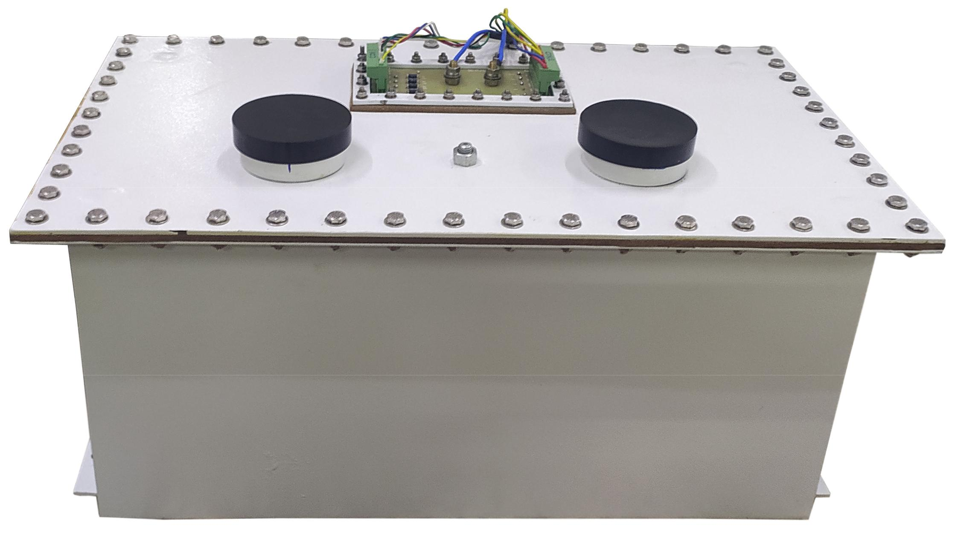
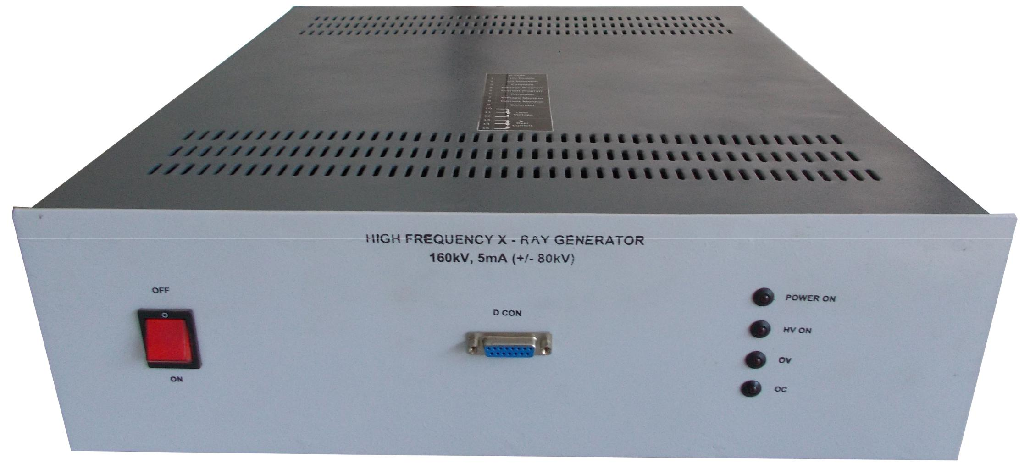
- Compact
- Superior Imaging
- Lower kV per exposure
- Microprocessor / PLC control
- Easy Serviceability

Technical Specifications
PARAMETER | SPECIFICATION
Input Voltage | 230V ±10% A C, 50Hz, single phase
No. of Output | 2
Output Voltage1  Output Voltage 2 | 125kV 160kV 220kV  0 to +62.5kV DC 0 to +80kV DC 0 to +110kV DC  0 to +62.5kV DC 0 to +80kV DC 0 to +110kV DC
Output Current | 0 to 5mA
Filament Voltage and Current | As per tube selection by OEM
Polarity | Positive and negative
Line Regulation | <0.1% for 10% variation in input voltage
Load Regulation | <0.5% for 10% load variation (tube current)
Mode of Operation | Constant voltage-constant current (x-ray anode current)
Protections | Overload, short-circuit and arc
Topology | SMPS
Cable and Connectors | To be supplied by the OEM
Housing  HT Tank  Inverter | MS tank (550mmx329mmx246mm)  19” Rack (440mmx458mmx142mm)
- OEM Customization Available
*Optional. To be specified by the user.

For any queries or customization requests contact us at info@ionics.co.in
For product line information visit us at www.ionics.co.in

